*NSEMBED Final Project*

Section: S12 & S13

Group No: 5

Members:

Azevedo, Marquus Joss

Fulcher, Lander Gabriel

Labindao, Carl Denzel

Malia, Gideon Andrew

**Change Control**

|  |  |  |
| --- | --- | --- |
| Version | Date | Comments |
| 0.1 | 07/20/2024 | Initial draft |
| 0.2 | 08/05/2024 | Final Output |

Table of Contents

I. System Overview 3

II. Results and Analysis 8

III. Conclusion 10

IV. References 10

Figure 1 Project Framework 4

Figure 2 RFID Reader Pin Description 6

Figure 3 LED Setup for RFID 6

Figure 4 RFID Pin Connections 7

Figure 5 Overall Hardware Setup 7

Figure 6 RFID Terminal Information 8

Figure 7 RFID Tag Tapping to the RFID Reader 8

Figure 8 Arduino Code for Server 9

Figure 9 Python Code for Server 9

# System Overview

The project focuses on the development of a specialized Transaction Server optimized for RFID Terminal operation, which is essential for managing and processing transactions from RFID-tagged devices. This server is crucial for ensuring seamless financial transactions and operational continuity in the service environment. Drawing from the foundational server architecture principles, our solution prioritizes scalability and reliability. We will implement robust concurrency techniques, such as multithreading and multiprocessing, to handle concurrent transactions efficiently. This capability allows the server to manage multiple transaction requests simultaneously, thereby ensuring high efficiency and responsiveness.

At its core, the server software is programmed to receive and process real-time data from the RFID tag readers. It validates the balance associated with each RFID tag and executes transactional actions based on current balance information. Emphasizing security, the system includes robust measures for secure transaction handling and user authentication, safeguarding against unauthorized access, and prioritizing data integrity. The project seamlessly integrates RFID Terminal hardware, utilizing server sockets and web application frameworks to establish a flexible and dependable infrastructure. This approach ensures that the server meets the distinct operational requirements of RFID-based transaction environments, maintains robust performance, and adheres to stringent operational standards.

The project represents an application of advanced server technologies tailored specifically for RFID Terminal operation. By combining theoretical insights with practical implementation, our goal is to enhance transactional efficiency, security, and reliability in contemporary financial and service sectors.

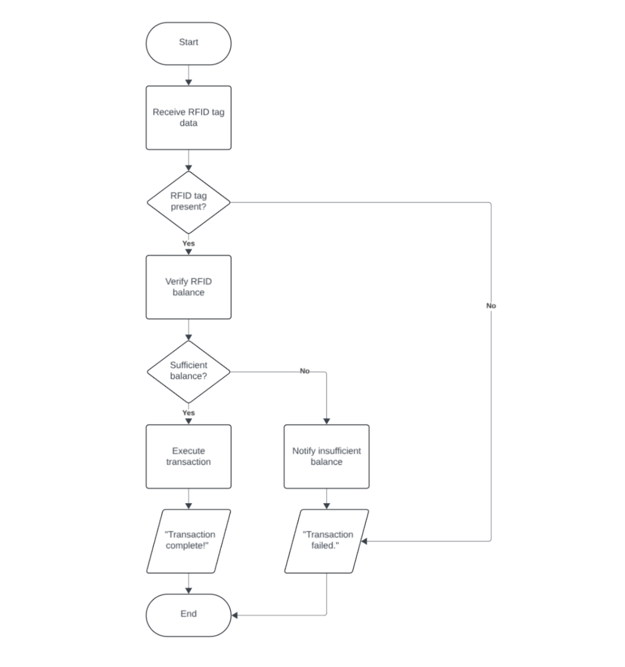

Figure 1 Project Framework

The flowchart outlines the transaction process facilitated by the RFID tag. Initially, the data were collected from the RFID tag. Subsequently, the system verified the presence and validity of the tag. If confirmed, the RFID balance is checked. Sufficient funds trigger transaction execution. Otherwise, a transaction failure notification is issued to the user.

**RFID and How it Works**

RFID stands for radio frequency identification, a type of wireless communication that uses electrostatic or electromagnetic coupling in the radio frequency region of the electromagnetic spectrum to identify a person, animal, or object uniquely.

RFID (Radio Frequency Identification) technology operates through the interaction of three primary components: a scanning antenna, a transceiver, and a transponder (RFID tag). The scanning antenna and transceiver are often combined into a single device known as an RFID reader or interrogator, which can be either fixed or mobile. The RFID reader transmits radio waves that activate the RFID tag within its read range. Upon activation, the RFID tag sends back a signal containing its stored information. This signal is received by the reader's antenna and decoded by the transceiver, converting it into usable data [1].

**RFID PIN Descriptions**

RFID (Radio Frequency Identification) systems use tags and readers to transmit data via radio waves. Here are the common pins found on RFID modules, typically used with microcontrollers like Arduino [2]:

VCC: Power supply pin. Connect this to a 3.3V or 5V power supply, depending on the module's requirements.

GND: Ground pin. Connect this to the ground of your microcontroller and power supply.

RST (Reset): This pin is used to reset the module. It is often active low, meaning it needs to be connected to ground to reset the device.

IRQ (Interrupt Request): This pin is used for interrupt-driven communication. It triggers the microcontroller when the RFID reader detects a tag.

MISO (Master In Slave Out): This is a data pin used in SPI communication. It sends data from the RFID reader to the microcontroller.

MOSI (Master Out Slave In): This is a data pin used in SPI communication. It sends data from the microcontroller to the RFID reader.

SCK (Serial Clock): This pin provides the clock signal for SPI communication. It is used to synchronize data transmission.

SS (Slave Select): This pin is used to select the RFID module for SPI communication. When the RFID reader is selected, this pin is pulled low.

SDA (Serial Data): In I2C communication, this pin is used for data transfer between the RFID reader and the microcontroller.

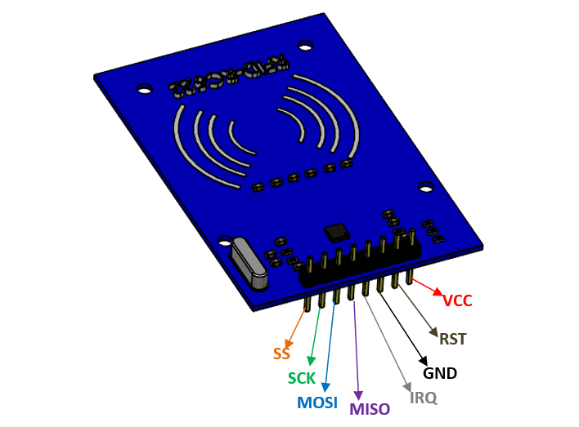

Figure 2 RFID Reader Pin Description

**Setup**

The following figures below show the hardware setup for the RFID project. This includes the LED on the breadboard, power bank, and the RFID pin connections.

Figure 3 LED Setup for RFID

Figure 4 RFID Pin Connections

Figure 5 Overall Hardware Setup

# Results and Analysis

For the RFID Terminal, it can be observed that the RFID terminal was able to send the time stamp, RFID tag information, and terminal ID which can be seen in the figure below.

Figure 6 RFID Terminal Information

It is observed that Figure 6 is already connected to the Wi-Fi router. When it is connected, the user taps the RFID tag to the RFID reader which contains the information and sent to the server. This prints the information in the server.

Figure 7 RFID Tag Tapping to the RFID Reader

In Figure 7, the RFID tag is tapped to the reader in which the information is sent to the server just like in Figure 6. An indication that the information is sent to the server when the LED bulb lights up.

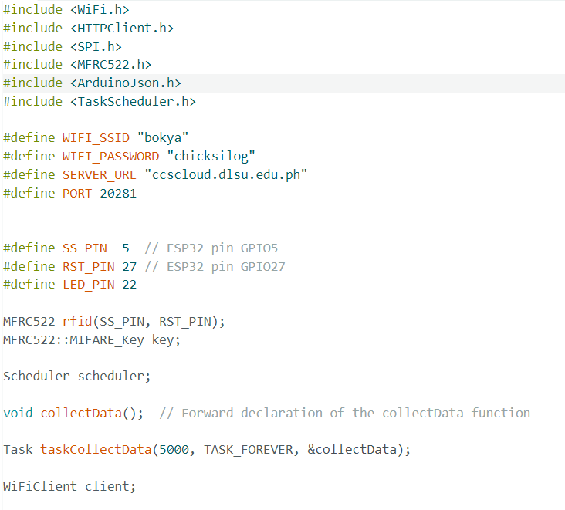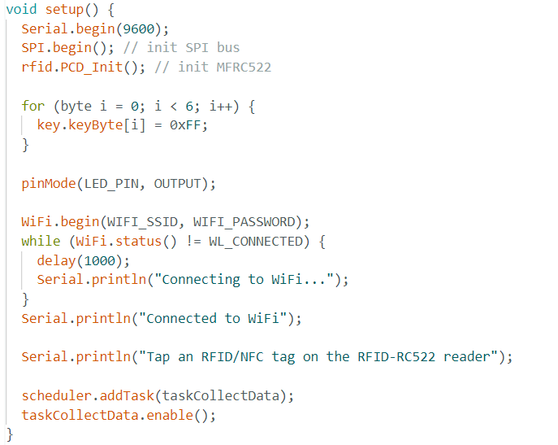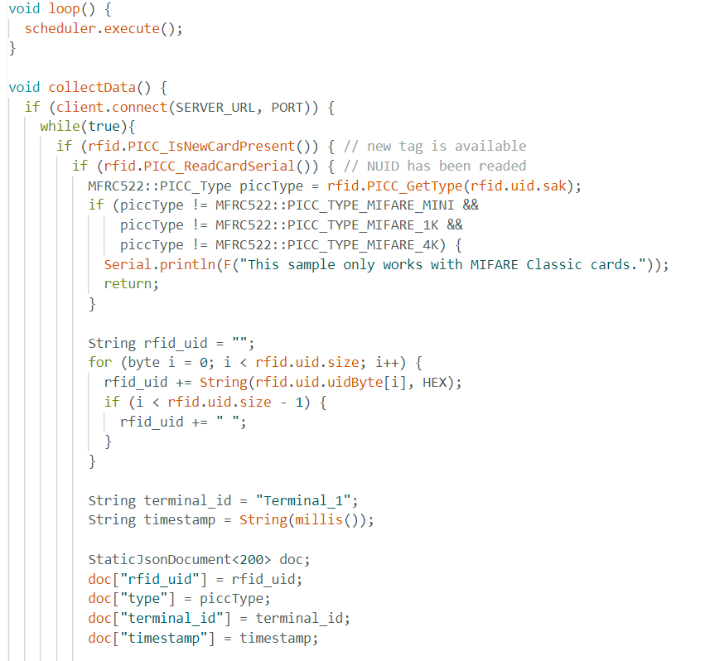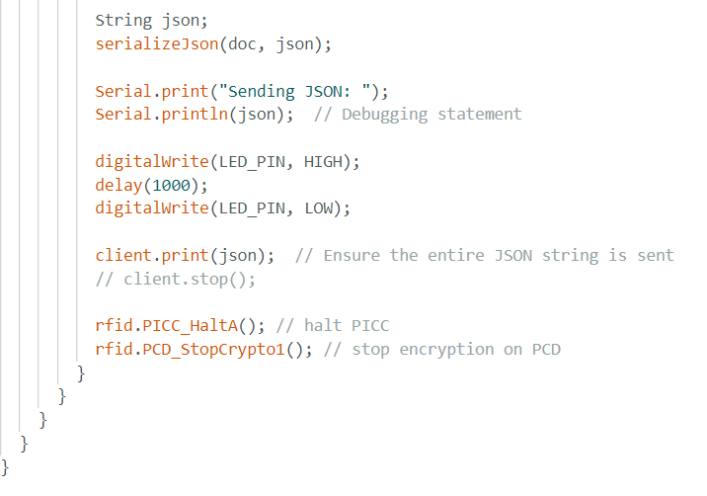

Figure 8 Arduino Code for Server

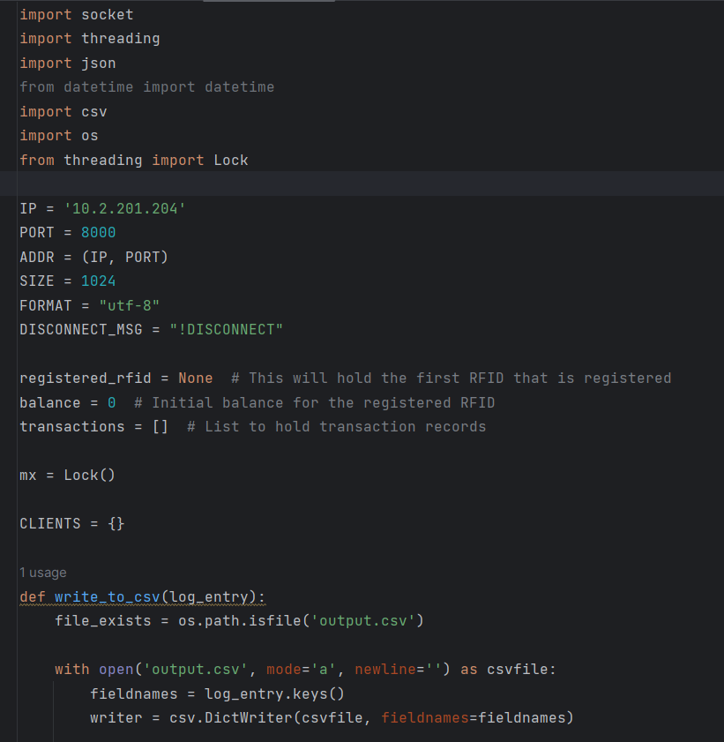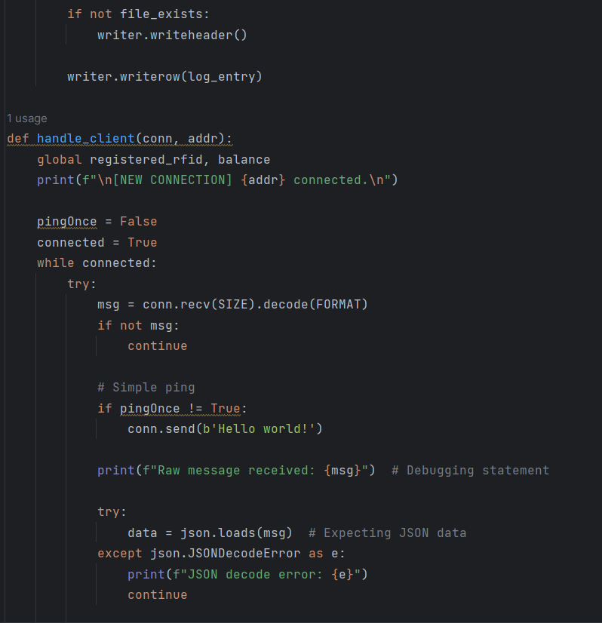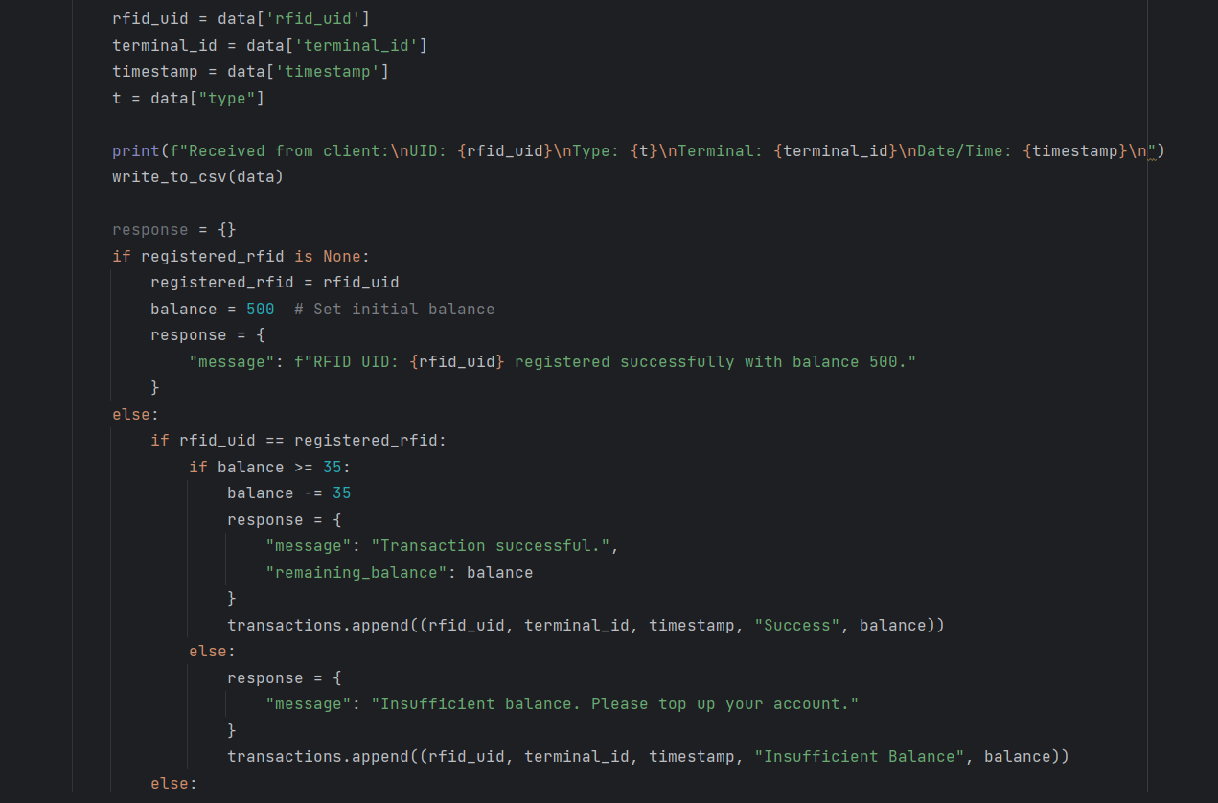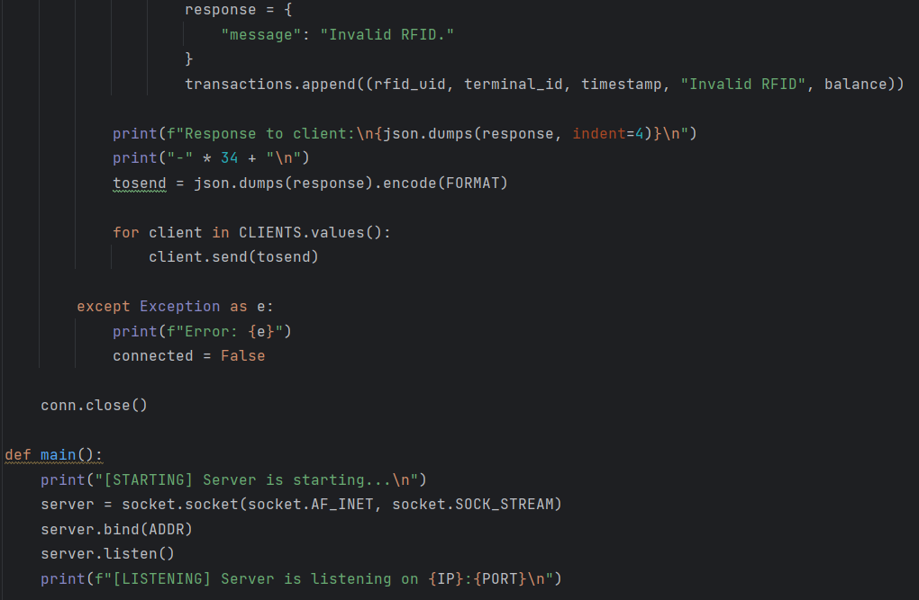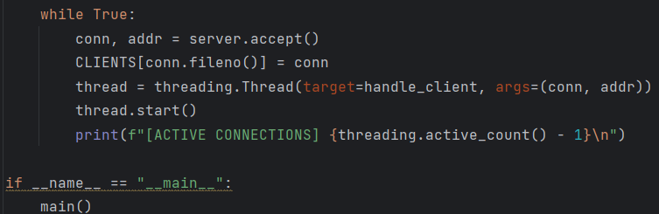

Figure 9 Python Code for Server

The two figures above show how the information is obtained from the RFID card. In Figure 8, this is the Arduino code that reads information from the RFID card then, it will be sent to the Python file which saves the information. In Figure 9, this is the Python code that receives the data from the card in which it will generate a csv file, prints the information from the RFID card and will be placed in the generated csv file.

# Conclusion

The primary objective of the project, which is to create an embedded system for RFID terminal operation and show off how well it can process transactions is achieved successfully. The system reliably performed transactions by capturing data from RFID tags using the ESP32 and RFID readers. We were able to implement this system effectively and output a CSV file containing the transaction information. The RFID terminal also included LED to indicate the status of each transaction. Overall, this embedded system effectively integrates RFID technology and server communication.

# References

|  |  |
| --- | --- |
| [1] | S. Amsler and S. Shea, "TechTarger," 31 March 2021. [Online]. Available: https://www.techtarget.com/iotagenda/definition/RFID-radio-frequency-identification#:~:text=RFID%20(radio%20frequency%20identification)%20is,an%20object%2C%20animal%20or%20person.. |
| [2] | [Online]. Available: https://components101.com/wireless/rc522-rfid-module. |